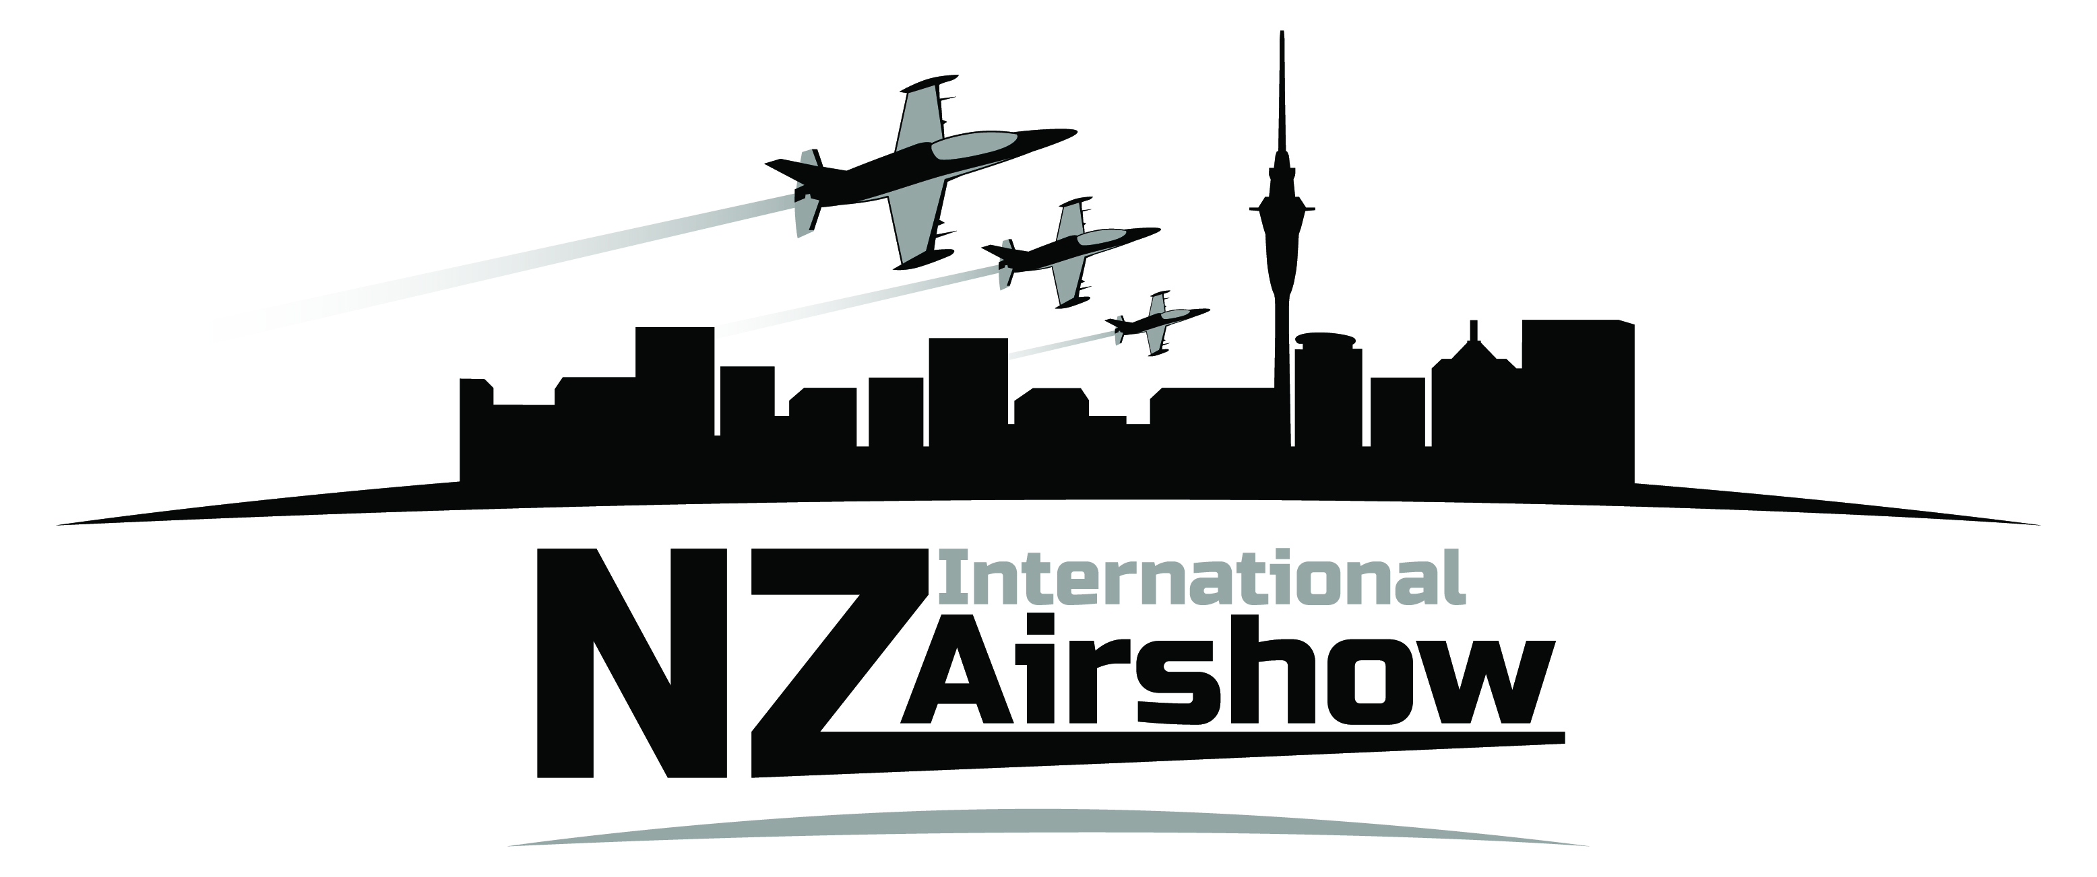

July 25, 2012

NZ International Air Show

Background Information

Traditionally, air shows are more about exhibition than competition.

The NZ International Air Show has the dual objective of showcasing New Zealand’s aviation industry and introducing the public to air racing and presenting the pilots as the true stars of air racing and the displays.

This is achieved through using advanced TV technology, on board cameras and large spectator screens, giving the audience the same views and experiences as the pilots.

The air show will also introduce different formats of air sports competition and will feature a number of world record attempts.

The NZ International Air Show has the support of the NZ $10 billion aviation industry.

Already, 38 percent of the aviation industry’s revenue comes from export markets, and the industry and Government recognise its growth potential. Some 1000 New Zealand businesses are involved in aviation activity.

Of the aviation industry’s $10 billion turnover, 70 percent of export and domestic revenues are generated from Auckland based companies.

International aircraft manufacturer Boeing is forecasting that over the next 20 years, the international aviation industry will require 460,000 additional pilots and 600,000 additional engineers to service projected growth. New Zealand is ideally positioned to contribute to filling this demand.

TV3 will transmit a one-hour news special on the air show on the evening of Anniversary Monday, and it will offer the show to major Australian TV networks and Discovery Channel.
Television coverage will give international viewers a never before seen aerial view of Auckland’s stunning waterfront and environs.
The event website is www.nzairshow.com.
For further information please contact
Peter Newport, Chief Executive Officer, Airshow Systems, Telephone (9) 446 6558, 021 380 318 peter.newport@airshowsystems.com.
Irene King, Chief Executive, Aviation Industry Association, Telephone (4) 472 2707, 021 936 838 irene.king@aia.org.nz.

Issued on behalf of Airshow systems by Network Communication (Dennis Lynch) Telephone (9) 3793 154, 021 963 733.
Note: Peter Newport is announcing the Air Show at the Oshkosh Air Show in the United States and will be returning to New Zealand immediately afterwards.

Misdmr001a

